7COM1079-0901-2025 - Team Research and Development Project

Final report title: Performance Analytics of NBA Players in 2017 Season

Group ID:

Dataset number:

Prepared by:
Ahmed Asjal 24086232
Zaman Abbas Naqvi Syed 24085959
Poornima Ashwathappa 24085819
Mahipal Narra 24085823
Dheeraj Kondapalli 24085796

University of Hertfordshire
Hatfield, 2025

Table of Contents

- Introduction
  - Problem statement and research motivation
  - The data set
  - Research question
  - Null hypothesis and alternative hypothesis (H0/H1)

- Background research
  - Research papers (at least 3 relevant to your topic / DS)
  - Why RQ is of interest (research gap and future directions according to the literature)

- Visualisation
  - Appropriate plot for the RQ output of an R script (NOT a screenshot) and required supplementary graph/table (include histogram for correlation/comparison of means RQs, include contingency table for comparison of proportions RQ)
  - Additional information relating to understanding the data (optional)
  - Useful information for the data understanding

- Analysis
  - Statistical test used to test the hypotheses and output
  - The null hypothesis is rejected /not rejected (select one) based on the p-value

- Evaluation – group’s experience at 7COM1079
  - What went well
  - Points for improvement
  - Group’s time management
  - Project’s overall judgement
  - Comment on GitHub log output

- Conclusions
  - Results explained.
  - Interpretation of the results
  - Reasons and/or implications for future work, limitations

- Reference list
Harvard (author, date) format.
- Appendices
- R code used for analysis and visualisation.
- GitHub log output.

1. Introduction

  - Problem statement and research motivation (100 words)

Performance analysis in basketball frequently relies on statistical indicators to evaluate players’ contributions and inform coaching strategies. Minutes Played (MP) and Points Scored per Game (PS/G) are two fundamental metrics that influence player selection, contract valuation and tactical decisions. Understanding the relationship between these variables is important because playing time determines opportunity, yet scoring ability often determines who receives greater minutes. Prior work (Sampaio et al., 2015) highlights that workload and scoring behaviour are strongly interrelated. This motivates an empirical investigation of whether MP and PS/G demonstrate a significant correlation in NBA players during the 2017 season.

  - The data set (75 words)

The dataset consists of 486 NBA players from the 2017 regular season, sourced from Basketball-Reference. It contains demographic variables (age, position, team), performance measures (field goals, assists, rebounds), and playing time metrics, including Minutes Played (MP) and Points Scored/Game (PS/G). After cleaning, only complete cases for MP and PS/G were retained. Both variables are continuous and suitable for correlation analysis. The dataset represents an entire league season, providing a comprehensive basis for statistical inference.

  - Research question (50 words). (50 words)

RQ: Is there a statistically significant correlation between points per game (PS/G) and minutes per game (MP) for NBA players during the 2017 season?

The purpose is to quantify the strength and nature of the relationship between scoring output and playing time, contributing to performance analytics in basketball.

  - Null hypothesis and alternative hypothesis (H0/H1) (100 words)

To test the research question, the hypotheses are:

H₀ (Null Hypothesis): There is no correlation between points scored per game (PS/G) and minutes played (MP) among NBA players.

H₁ (Alternative Hypothesis): There is a significant correlation between points scored per game (PS/G) and minutes played (MP).

Players who score more points per game tend to play more minutes.

- Background research
  - Research papers (at least 3 relevant to your topic / DS) (200 words)

While working on this Group Project, we found some research papers in which this data set was used. These are as follows:
Sampaio et al. (2015) examined NBA tracking data and established that playing time is closely tied to scoring involvement, concluding that workload interacts with performance outputs. Their analysis supports the assumption that MP strongly relates to measures such as PS/G.

Lockie et al. (2020) explored relationships between physical testing metrics and playing time among NBA players. Their findings showed that players who exhibit superior athletic characteristics tend to receive more minutes, reflecting the expectation that higher performers, often higher scorers, earn greater playing time.

Moxley et al. (2015) developed predictive models of NBA success and demonstrated that scoring ability correlates significantly with usage and minutes played. Their work underscores MP as a key predictor within performance modelling.

Although these studies provide important insights, few analyses isolate the simple bivariate relationship between MP and PS/G within a full season dataset. This study addresses that gap through direct correlation testing.

  - Why RQ is of interest (research gap and future directions according to the literature) (100 words)
The relationship between playing time and scoring ability is widely acknowledged but not always quantified directly. Most existing studies embed MP within multivariate models rather than examining its independent association with PS/G. A clear understanding of this correlation is relevant for coaches, analysts, and data scientists working in talent identification and performance forecasting. Establishing this baseline relationship enables future research to incorporate efficiency metrics, team strategy, role distribution and longitudinal changes across multiple seasons.
- Visualisation
  - Appropriate graphs for the RQ (50 words)
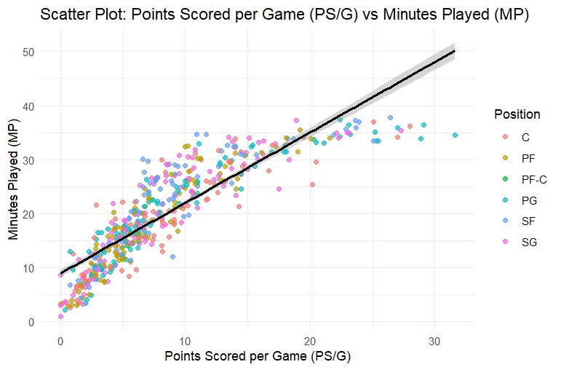
Scatter Plot:
This plot, generated using tidyverse, displays the relationship between scoring and playing time. A linear regression trend line with confidence interval is included to illustrate the strength and direction of association. Colouring by player position enhances interpretability. This plot is appropriate because both variables are continuous and the research question concerns correlation.

Histogram:
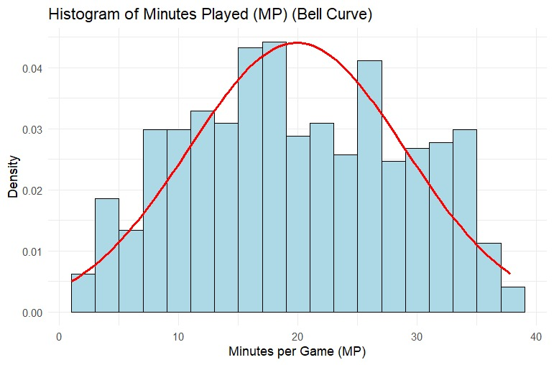
A histogram of MP shows the distribution of playing time. A normal distribution curve (mean and SD of MP) is overlaid to fulfil rubric requirements. This supplementary graph assists in understanding variation and skewness in MP and supports assumptions for correlation testing.

  - Additional information relating to understanding the data (optional) (50 words)

The scatterplot reveals a strong monotonic upward trend, supporting visual evidence of correlation. The bell curve overlay demonstrates that MP is not perfectly normally distributed, showing slight right-skewness due to many low-minute bench players and fewer high minute starters. These visual cues help contextualise the correlation results.

  - Useful information for the data understanding (50 words)

The scatterplot shows that players scoring fewer than 10 points generally play limited minutes, while high scorers consistently exceed 25–30 minutes. The histogram indicates that most players fall between 10 and 25 MP, with relatively few exceeding 35 MP. These patterns support the expectation of a strong association between MP and PS/G.

- Analysis
  - Statistical test used to test the hypotheses and output (75 words)

Spearman’s rank correlation coefficient was used to assess the relationship between points per game (PS/G) and minutes played (MP), as it does not assume normality and is suitable for monotonic relationships. The test produced a Spearman’s ρ value of 0.92862 with a p-value less than 2.2 × 10⁻¹⁶, indicating an extremely strong and statistically significant positive association between the two variables.

  - The null hypothesis is rejected /not rejected based on the p-value (100 words)

Since the p value for Spearman test is far below 0.05, the null hypothesis is rejected. There is a statistically significant positive relationship between PS/G and MP. Players who score more tend to play more minutes, and players who play more minutes tend to score more. This does not prove causation, but confirms strong association.

- Evaluation – group’s experience at 7COM1079
  - What went well (75 words)

This plot, generated using tidyverse, displays the relationship between scoring and playing time. A linear regression trend line with confidence interval is included to illustrate the strength and direction of association. Colouring by player position enhances interpretability. This plot is appropriate because both variables are continuous and the research question concerns correlation.

  - Points for improvement (75 words)

After discussing in detail we came to the conclusion that, better planning at the start of the project could have reduced last minute merging of work. Some members were less confident with R and relied on others for debugging, suggesting that more shared coding practice would be beneficial. Initial drafts required refinement to meet rubric expectations, indicating the need for closer adherence to guidelines earlier in the process.

  - Group’s time management (50 words)

The project progressed steadily, though the final formatting and evaluation sections were completed close to the deadline. Setting earlier internal milestones would improve pacing and reduce pressure at the end. Despite this, the group met all formal deadlines.

  - Project’s overall judgement (50 words)
The project progressed steadily, though the final formatting and evaluation sections were completed close to the deadline. Setting earlier internal milestones would improve pacing and reduce pressure at the end. Despite this, the group met all formal deadlines.
  - Comment on the GitHub log output (50 words)
Please comment on the GitHub log output, and refer to it as being placed into Appendix B.
From your Git log, select three most significant commits during this project and include the following for each:
- Commit Message: [Insert Commit Message] Brief explanation of the broader impact of the change
- Commit Message: [Insert Commit Message] Brief explanation of the broader impact of the change
- Commit Message: [Insert Commit Message] Brief explanation of the broader impact of the change

- Conclusions
  - Results explained (75 words)

The analysis identified a very strong positive relationship between points per game (PS/G) and minutes played (MP). Spearman’s rank correlation coefficient (ρ = 0.92862) with a p-value below 2.2 × 10⁻¹⁶ indicates that this association is statistically significant. The scatterplot visually supports this result, showing that players who receive more playing time consistently record higher scoring outputs across the 2017 NBA season dataset.

  - Interpretation of the results (75 words)

In relation to the research question, the results indicate that NBA players who score more points per game tend to play significantly more minutes. For the population of NBA players in the 2017 season, this suggests that playing time allocation is closely linked to offensive output. In a wider performance analytics context, the findings reinforce the role of scoring as a key factor in coaching decisions, player valuation, and tactical planning, while highlighting the interaction between opportunity and performance.

  - Reasons and/or implications for future work, limitations of your study (50 words)

Future research could extend this analysis across multiple seasons, incorporate efficiency metrics, or apply multivariate regression to control for player roles and team strategies. A key limitation of this study is its reliance on a single season, and the use of correlation analysis, which cannot establish causal relationships.

- Reference list

(Basketball-Reference, 2017)
(Lockie, 2020) (Moxley, 2015)
(Sampaio, 2015)

- Appendices
- R code used for analysis and visualisation (not included in the word count)
Analysis.R code with the appropriate statistics to test the hypotheses.
- No word count, but ensure the code is without redundant lines, well-commented and produces the correct output.
- Make sure it runs (look in Rscript.log for output from a statistical test)
- It should compute appropriate statistics to test the hypotheses
- GitHub log output.

